## TestNG

## What is TestNG?

### Can only be used with java.

### TDD (Test Driven Development) framework

### Unit test framework

### Open source

### Available in form of jar files

### Also called java unit testing framework

### Generate very good html reports.

### Gives lot of annotations

### Lot of features like priority, sequence of test cases, dependency feature, grouping, data provider feature

### Design test cases in a systematic way.

## Install TestNG in eclipse!

## First Approach:

### Windows->install new software -> give this <http://beust.com/eclipse/> in available software and Press enter.

### Select TestNG in the list. All lists make sure selected and click next-> Next->Accept license-> Finish.

### Click ok for security warning.

## Second Approach:

### Help->Eclipse Marketplace->Type TestNG and enter->TestNG for eclipse will be listed->Click Install

### Then we must add TestNG jars (add dependency in maven project, jars will be installed automatically under maven dependencies)

### Click project->properties->java build path->add library-> select TestNG (if installed properly))-> ok.

## No more Main Method

### In windows->Preferences->search testNG. If it is listed, then testNG is successfully installed in eclipse.

### When u have main method then test will run on java compiler but in testNG no main method is required because testNG acts as java compiler, so u don’t need to depend upon java compiler.

### As u removed main method so when we give run as we don’t have any option to run as java application now run as testNG test

### We don’t need the main method to execute our class. Don’t write main method in TestNG.

## Creating TestNG xml file in eclipse:

## Approach 1:

### Right click on project folder->TestNG->Convert to TestNG->Next->Finish.

## Approach 2:

### In this approach u must enter xml data manually.

### Right click on project->New-> File->Enter file name “Testmg.xml”->Finish.

## Annotations:

### Control the sequence and priority of methods.

### Annotations should start with @

### Every annotation should be associated with one method.

## Prerequisites Annotations or Preconditions:

### **@BeforeSuite:**

### This method will run before the execution of all the test methods in the suite.

### **@BeforeClass:**

### This method will get executed only once before executing first Test method present in the current class file

### **@BeforeTest:**

### This method will get executed multiple times before executing each and every class (Test blocks)

### **@BeforeMethod:**

### This method will get executed multiple times before executing each and every Test method present in the class file

## Testcases:

## @Test

### Marks a class or a method as a part of the test.

## Postconditions:

### **@AfterMethod:**

### This method will get executed multiple times after complete execution of each Test method present in the class file.

### **@AfterTest:**

### This method will get executed multiple times after complete execution of each class(test blocks)

### **@AfterClass:**

### This method will get executed only once after complete execution of all Test method present in the current class file(ie after completion of all methods present in class)

### **@AfterSuite:**

### This method will run after the execution of all the test methods in the suite.

## TestNG XML file:

### Play important role.

### Execute multiple Test cases as a suite.

### Create and execute suits parallelly.

### Pass parameter from XML file to Test cases

## Hierarchy of the TestNG Annotations:

### @BeforeSuite.

### @BeforeTest.

### @BeforeClass.

### @BeforeMethod.

### @Test.

### @AfterMethod.

### @AfterClass.

### @AfterTest.

## Annotations Helper Attributes:

## Priority

### By default, testNG executes the methods in alphabetical order

### We can pass parameter call priority to execute in the required order.

### We can give the priority in random number also whichever number has priority =0 it will execute that method even it is present in last. So, order is not a matter over here

### @Test(priority=2)

## Enabled

### If I have 10 test methods but I don’t want to execute few methods, then I can disable those methods. Even it has the priority = 1/2/3 etc… I will not get executed.

### To do that we can use enabled = false

### By default, enabled = true in testng

### @Test(enabled=false)

## DependsonMethods

### When the second test method wants to be dependent on the first test method, then this could be possible by using "**dependOnMethods**" attribute.

### If the first test method fails, then the dependent method on the first test method, i.e., the second test method will not run.

### Single value: @Test (dependsOnMethods= {"WebStudentLogin"})

### Multiple value: @Test (dependsOnMethods= {"testcase3","testcase2"})

## alwaysRun Property

### This is used when we want to make sure a method always runs even if the parameters on which the method depends, fails.

### Even Method 1 fails method 2 will get executed because of the always run property

### @Test(dependsOnMethods = "method1", alwaysRun=true)

### Public vod method 2()

### {

### }

## Description:

### It is a string which is attached to the @Test annotation that describes the information about the test.

@Test(description="This is testcase1")

**public** **void** testcase1()

{

System.out.println("HR");

}

## timeOut

### If one of the test cases is taking a long time due to which other test cases are failing

### The timeOut is a period provided to the test case to completely execute its test case.

### @Test(timeOut=200)

### public void testcase1()

### {

### }

### Testcase1() will be failed after 200 milliseconds.

## Grouping

### The 'groups' attribute is used to group the different test cases that belong to the same functionality.

## Class file

**public** **class** Software_Company

{

@Test(groups= {"Sanity"})

**public** **void** infosys()

{

System.out.println("Sanity TC");

}

@Test(groups = {“Regression”})

**public** **void** technip()

{

System.out.println("Regression TC");

}

@Test(groups= {"Sanity",”Regression”})

**public** **void** wipro()

{

System.out.println("Sanity and Reg TC");

}

## XML:

<suite name="test_suite">

<test name="GroupingTesting">

<groups>

<run>

<include name="Sanity"/>

</run>

</groups>

<classes>

<**class** name="com.javatpoint.GroupingExample"/>

</classes>

</test> <!-- Test -->

### What all Test methods part of sanity then all those will get executed

### If I want to execute both sanity and regression in XML tag I can specify one more group in include tag

### <include name =”Sanity”/>

### <include name="Regression"/>

### If I want to execute only sanity then I cant also use exclude tag to exclude regression

<exclude name="Regression"/>

### If there are two values as given below in script this group will not get executed even if it has sanity because in exclude tag we have given regression so regression is part of this group(combo also not get executed in exclude tag)

@Test(groups= {"Sanity",”Regression”})

## ****Optional parameters in TestNG:****

### **Even if we didn’t pass any value in xml still it will work. It will contain default value in it internally.**

### **Default value will be considered as parameter value and proceed with execution.**

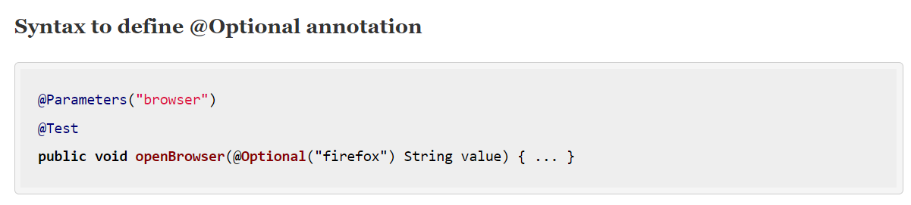

### **Parameter tag should contain two values name and value**

### **Parameter can be passed from suite level as well as test level**

### **If you want to pass the parameter that is common across all the test cases then pass it as suite level**

### **If you want to pass the parameter in test level then the scope of parameter will be only limited to test case only**

## ****Timeout Attribute****

### **If you are expecting any test method to be completed within specified time then we have to specify the specified time inside the timeout attribute**

### **If your method is taking more than mentioned time then TestNG is going to fail that method. To achieve this functionality Timeout attribute is used**

### **Accept time in milliseconds.**

### **It will throw ThreadTimeOut Exception**

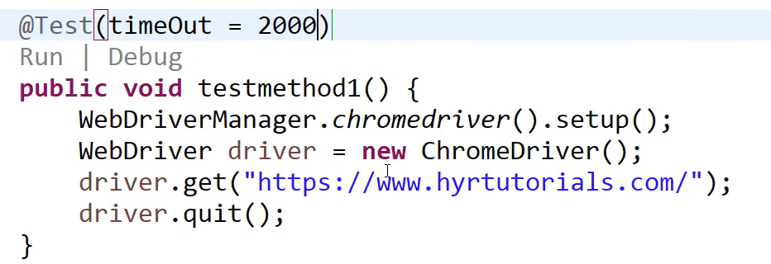

## Excepted exceptions:

### Specific or multiple exceptions is expected by the tester to be thrown from the test method.

### If the exception is not thrown so its failing

### This helps in verifying that the expected behaviour is working as intended.

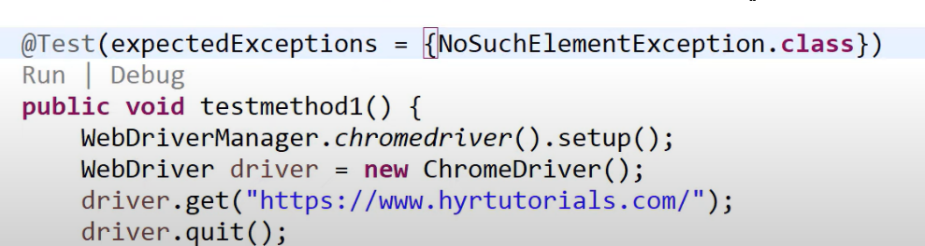

## InvocationCount:

### Using invocation count we can execute same piece of code(same Test) multiple times and yet we can track each and every iteration. Even one iteration failed it will execute the rest of the iteration.

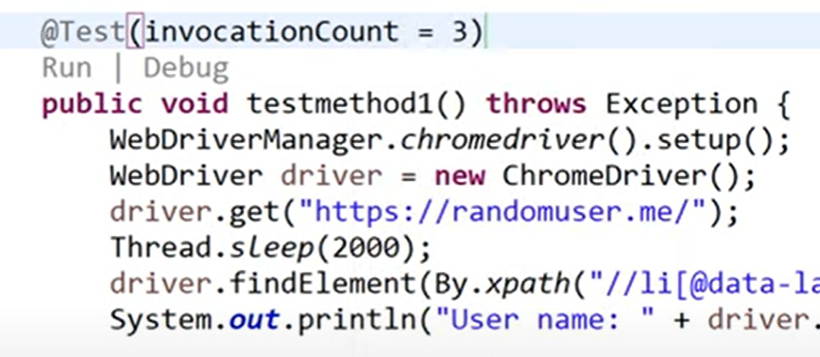

## InvocationTimeout

### **If your invocation method is taking more than mentioned time, then TestNG is going to fail that method. To achieve this functionality invocation Timeout attribute is used.**

### **Thread count is only useful if we provide the parallel attribute value.**

### **Invocation timeout is only useful if we provide invocation count. Cannot define it separately.**

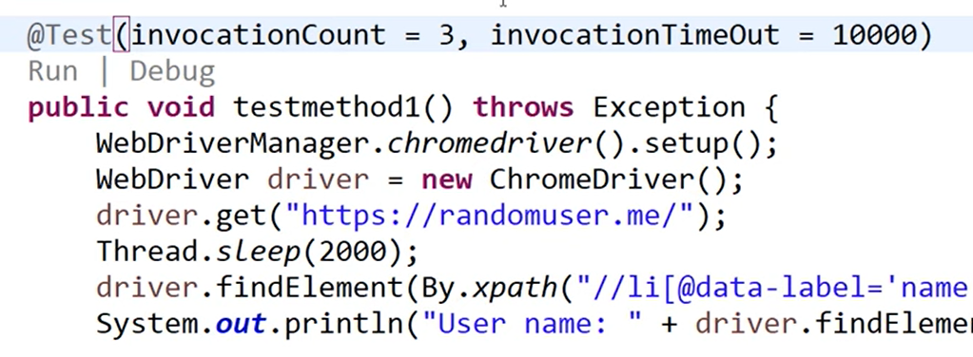

## ****Threadpool Size:****

### **Whatever invocation we are planning if we want to execute it in threaded mode then use threadpoolsize.**

### **Used to create no of threads for invocation count.**

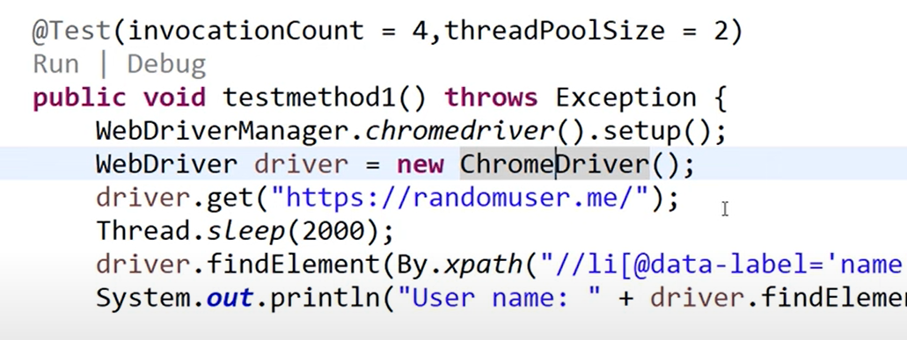

## Types of Assertions:

### Soft Assertions

### Hard Assertions

## Hard Assertions

### Assert class assertion methods are all falls under hard assertion.

### Throws exception immediately upon failure and stop the execution.

### Whenever assertion fails it will not execute the rest of the code (next step will become unreachable code) which is present after the assertion

### It will come out of the entire test method and goes to the next test method.

## Assert – class

### If we import assert class in the test class then we don’t need to mention assert.assertEquals everytime just mention assertEquals can be directly mentioned

### So import assert.* to import all methods of assert class

## ****Assert.assertEqual(String actual, String expected):****

### To validate if the actual string is equal to the expected string or not.

## ****Assert.assertEqual(String actual, String expected, String message):****

### This assertion method is similar to the assertion method discussed above; the only difference is that this method can accept one more string parameter as a message.

## ****Assert.assertEquals(boolean actual, boolean expected):****

### This assertion method accepts two boolean values and validates if both are equal or not.

## ****Assert.assertTrue(condition):****

### This assertion method is used to assert whether the condition passed in a parameter returns true or not. If the condition returns false, the assertion error is thrown.

## ****Assert.assertTrue(condition, message):****

### This assertion method is similar to the assertion method discussed in previous one, the only difference is that this method can accept one more string parameter as a message.

## ****Assert.assertFalse(condition):****

### This assertion method is used to assert whether the condition passed in a parameter returns false or not.

## ****Assert.assertFalse(condition, message):****

### This assertion method is similar to the assertion method discussed in the previous one, the only difference is that this method can accept one more string parameter as a message

## ****Assert.assertNull(condition):****

### This assertion method is used to assert whether the condition passed in a parameter returns null or not. If the condition doesn’t return null, the assertion error is thrown.

## Assert.assertNotNull(condition):

### This assertion method is used to assert whether the condition passed in a parameter returns value except null or not. If the condition returns null, the assertion error is thrown.

## Soft assertion:

### If assertion is coming from SoftAssert class, then it is called soft assertion

### Throws exception at end of the test.

### The statement that are written after the assertion also will be executed.

### Control is in our hand so we can decide whether those statements should be executed or not be executed.

### I don’t want to execute test again and again for verification even one field fail I want test to get executed for all other fields. All assertions report I must get.

### SoftAssert class don’t have any static methods, so we must create object in the class.

### Same methods as Asserts class are present here also.

### Softassert will record the failure but will not throw exception immediately.

### If we call assertAll it will throw the exception at end of the test. If there is no exception, then it will not throw any. Using this assertAll exception will not be thrown immediately in failure part it will be thrown at the end. So, all code will get executed.

### **Soft assert does not include by default in TestNG**. For this, you need to include the package **org.testng.asserts.Softassert.**

## Parametrization supports in two ways in TestNG:

Approach 1: Parameters in TestNG:

### Any scenario must be executed with different set of data then this can be achieved with parameterization.

### Using xml file, we can pass parameters to test cases.

## **Approach 2:** **Data Provider**:

### The method which is providing the data to the other method is called DataProvider.

### **It is a container which passes/supply data to our test method so our test method will execute with different set of data.**

### **To parameterize data to our test method. We can have n no of Data provider container in TestNG class. So how to identify that by using name for each data provider.**

### **If we hardcode the value in script, it can only be test with one data (that particular data).**

### **If we want to test the same scenario for different data, then again, we have to repeat the steps again and again.**

### **Now we want to resuse the same code but with different set of data.**

### **Combination of multiple one-dimensional array is two dimensional array (multiple rows and each row having multiple columns)**

### **In case if we are not passing any name to the dataprovider then we can use the data provider method name itself as a name for the data provider.**

### It is annotated with @DataProvider annotation.

### It should contain some name.

### Same data provider name we must refer it in the actual test method (where to pass data).

### DataProvider method will return two-dimensional array.

### Can be used in same or different class.

### This method is creating some data and returning the same data.

### The actual method will repeat multiple times depends on the data which is passed by the dataprovider method.

### We don’t need to use loop here that’s the advantage of dataprovider

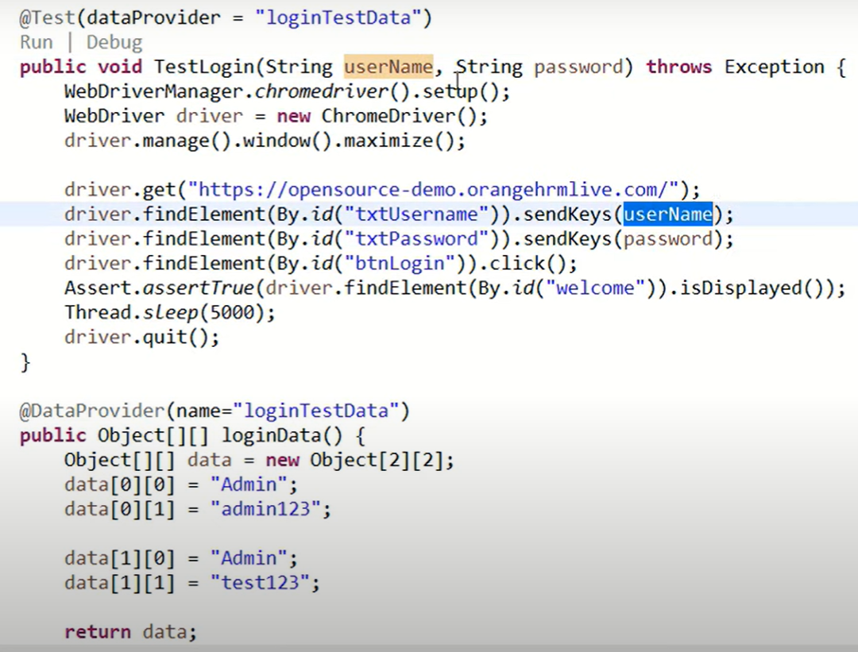

### **Total set of data is 2 but one test method but total test will be 2 in Console based on iteration.**

## ****Dataprovider Return Type:****

### **Dataprovider has multiple return type.**

### **It is not mandatory to return only object two dimensional array we can return other return type .**

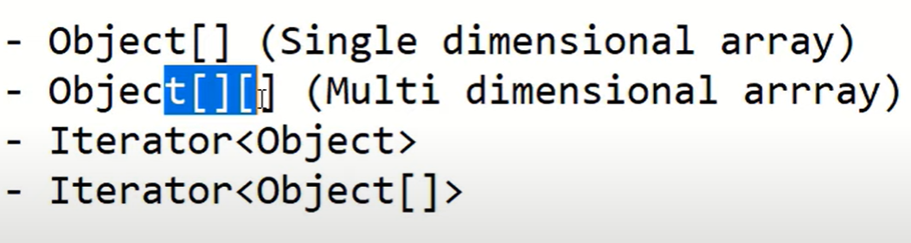

### **Object - any datatype(predefined /userdefined)**

### **It can be String[], Integer[], Float[]**

### **Employee[] – User define**

### **For all class in java the super class is object**

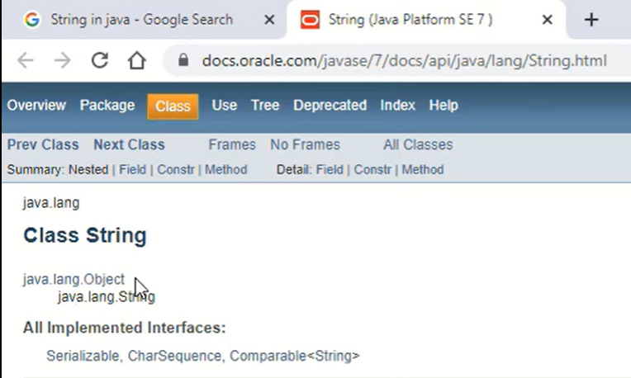

### **Simply mentioning Object instead of mentioning String etc etc.**

## ****Single Dimensional Array with String****

### **String[] – Combination of multiple strings**

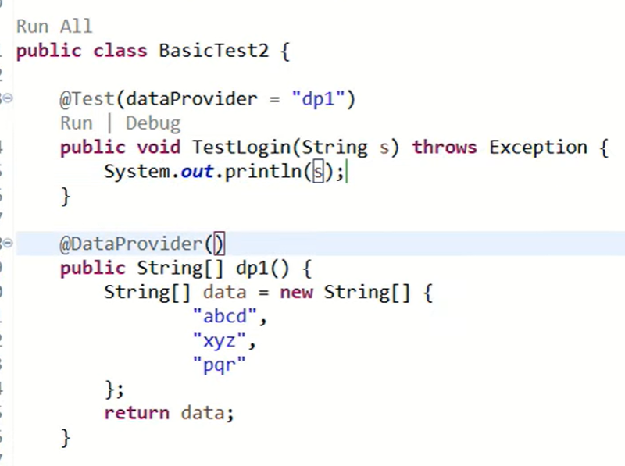

## ****Single Dimensional Array with Integer****

### **Int[] – Combination of multiple Integers**

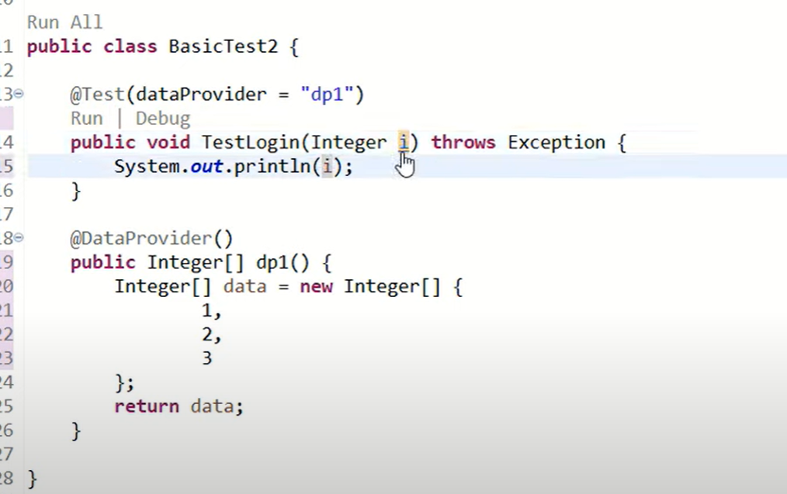

### **When and why, we need to use Object Array?**

### **When we know what type data, we are storing in data provider then we can mention the respective return type.**

### **But if we don’t know wat type of data storing or storing multiple types of data (1, qbc,1.0 etc) then we can use Object Array. Because the super class of all other data type class in object**

## ****Two-dimensional Array****

### **For every row the column count will be same**

## ****Approach1:****

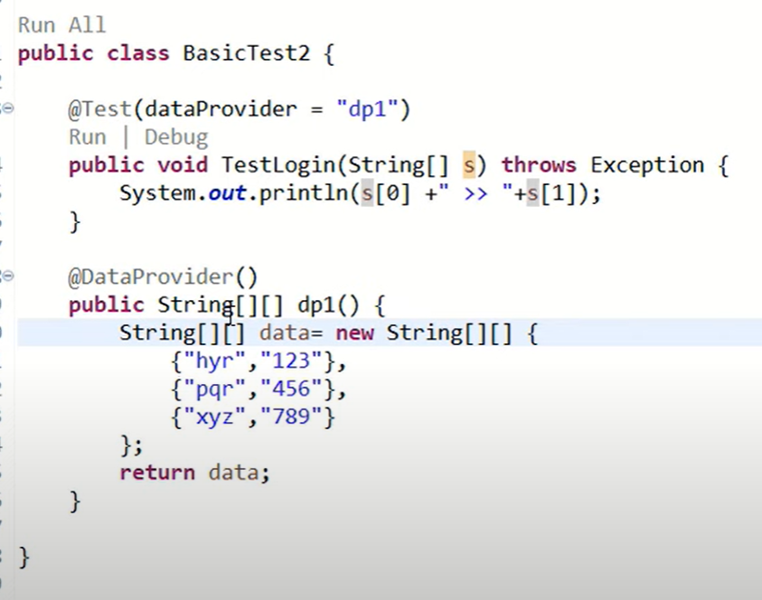

## ****Approach 2:****

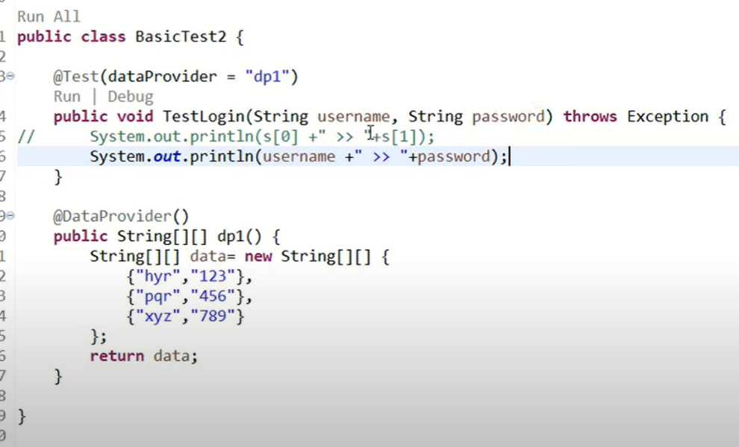

### **If I have 50 parameters, then it is hard to write 50 method signatures. Now we have two, so we written Username and Password**

### **In that case I mention single variable as approach 1 and read the values using index format**

## ****Jagged Array****

### **Colum count varies from row to row**

### **We cannot pass parameter to methods if we have this type of array**

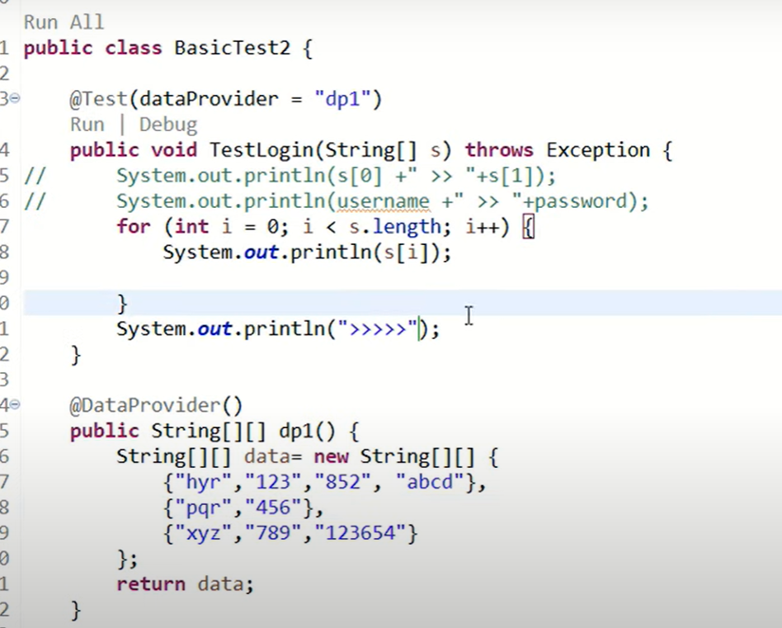

## ****Iterator<Object>:****

### **Used to read values from collections not applicable to array.**

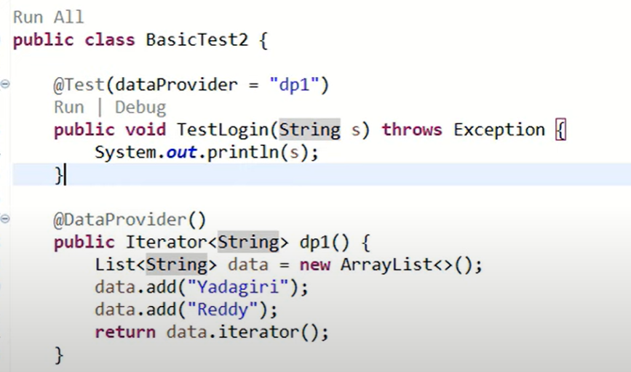

### **To store arrays into list /set as below**

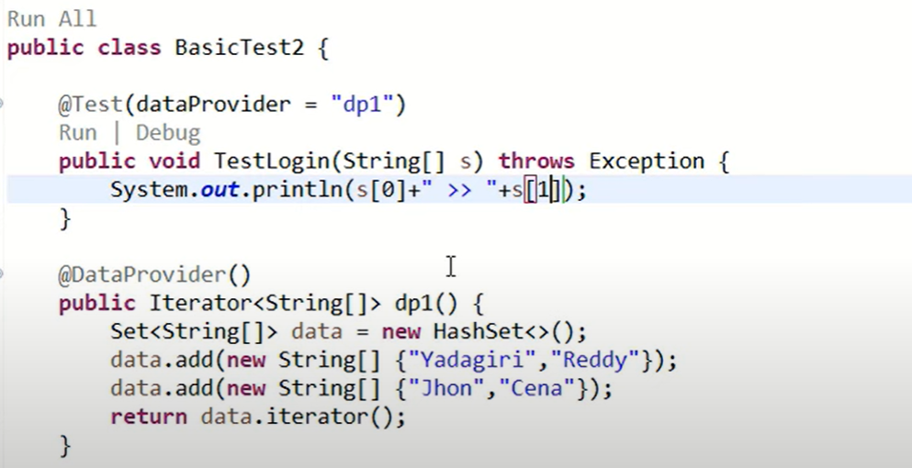

### **To use a part of Dataprovider Data into our test methods using Indices concept**

## ****Indices****

### **Whatever the data u wants to pass those data index is called indices.**

### **It is a parameter in data provider annotations. We have to pass the index array.**

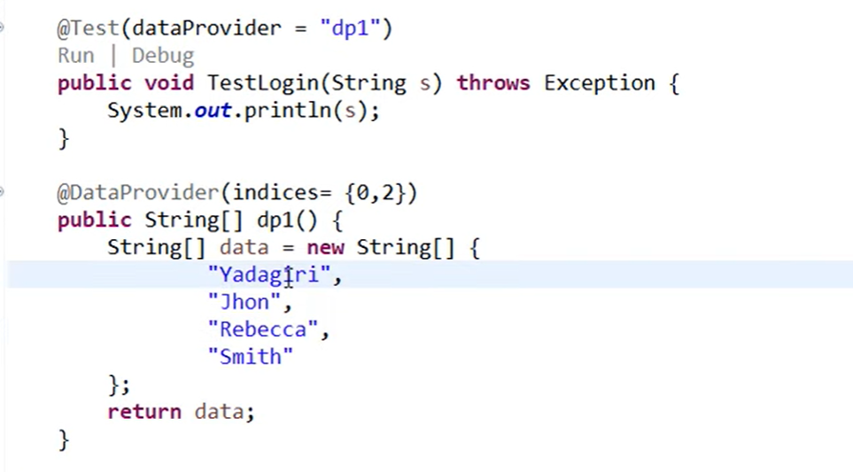

## ****When to use indices in real time?****

### **When we have 100 sets of data and when we execute 90 passed and 10 failed now, I want to closely observe only those 10-test data. If I want to re-execute, then all dataset will get executed so to avoid that we use indices concept to execute/debug only those 10 data set**

## ****DataProvider in different class****

### **By default, when we use dataprovider in test method then it search for the dataprovider with the specified name in same class but we defined it in another class.**

### **To achieve this we have a parameter dataproviderClass attribute. Using th is we can specify in which class our dataprovider is actually residing.**

import org.testng.annotations.Test;

public class DataProvider {

@Test (dataProvider = "data-provider", dataProviderClass = DP.class)

public void myTest (String val) {

System.out.println("Current Status : " + val);

}

}

## ****Integration of Excel with Dataprovider****

### **If you want to modify the data, then you need to come to the code level and changing the data in java class files and you want to modify the data that is not good practice.**

### **So, our dataprovider should be able to fetch the data from an external source and then supply it to the test method.**

### **We want to keep data in one source to supply data dynamically.**

### **Libraries available for reading data from excel file.**

### **Excel file is a tabular form of data.**

### **Extension for excel file is xls(old version of excel file),xlsx(new version of excel file)**

## ****Two famous libraries available for reading and writing data from excel****

### **Apache POI**

### **JXL**

### **Apache POI support both version of excel files**

### **JXL supports only older version of excel file but it is faster then POI**

## ****Downloading and installing of Apache POI Java library****

### **Two libraries need to be downloaded from maven.**

### **Apache POI -poi**

### **Apache POI – poi ooxml.**

## ****How to read data from excel file dynamically?****

### **Excel is a Workbook**

### **Inside workbook we have multiple sheets**

### **In each sheet we have data**

### **In each sheet we have -> Row**

### **Row-> Column/Cell**

### **Workbook->Sheet->Row->Cell**

### **Add Excel file in Resources Folder. To save excel in older version select “Excel 97-2003 Template” if newer version the select “Excel Workbook”.**

### **If we want to handle any file(external source) in java then we have to create File**

### **File** **excelfile = new File(“Path”);**

### **If you want to read any data from the file then we have to create streams. Only file instance is created but we haven’t read the data**

## ****Read the raw data from excel file****

### **FileInputStream fis = new FileInputStream(excelfile);**

## ****Convert the data into excel data(Workbook) format****

### **When the extension is xls ->H**

### **When the extension is XLSX -> X**

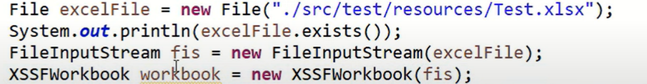

### **Now we have to get the sheet from the workbook.**

## ****Two methods we have****

### **getSheet()-Sheet name we have to pass**

### **getSheetAt() – Index of the specific sheet**



### **To get the row first we have to understand how many rows with data are present inside the sheet.**



### **Save the noofrows in a variable**



### **Now we have to know how many columns are present in each row . Always make sure that u will get the no of columns from the header row only**



### **From sheet only we have to get rows ->Sheet.**

### **From header(first) row we can know how many columns are present-> getRow(0)**

### **To Give u how many no of columns are present -> getLastCellNum()**

### **This return as index values. If we have 4 rows then it returns value as 3(0,1,2,3)**



## ****To Access Data from row and column****

### **(Int i = 1) or (i< noofRows-1)=> We don’t need header row. Sometimes i=1 will throw exception so use second approach**

### **DataFormatter class**and method formatCellValue = Used to convert any type of data into string or text type of data***.***

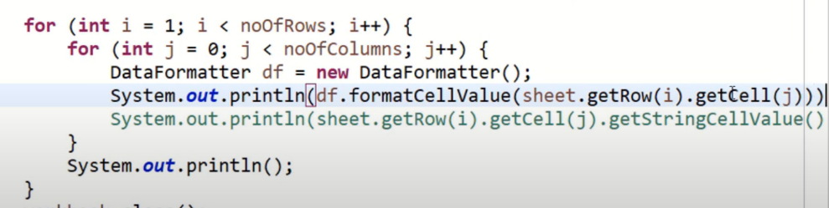

### **Then close the workbook and sheet.**

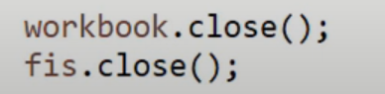

### **Prepare data array because in data provider we must use array only.**

### **Store data in two-dimensional array because whenever we are using data provider, we have to return two dimensional array.**

### **Create dataprovider by reading data from excel.**

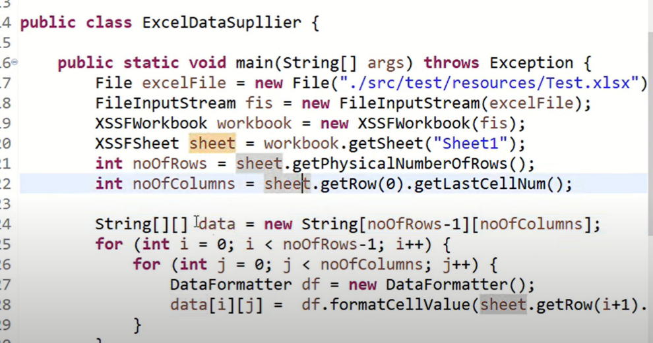

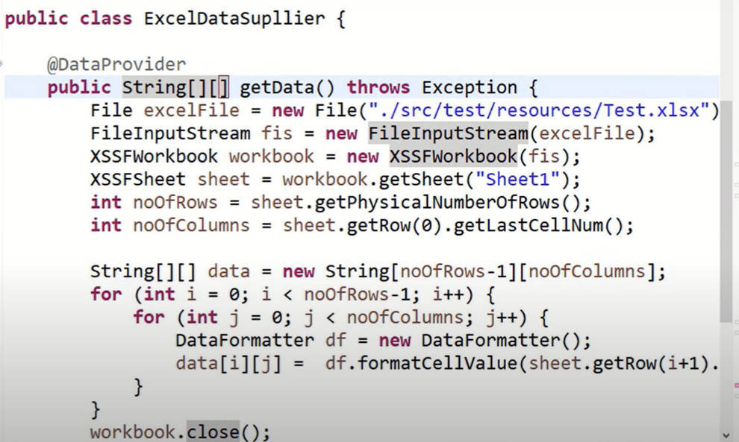

## ****Execute the dataprovider test method parallely****

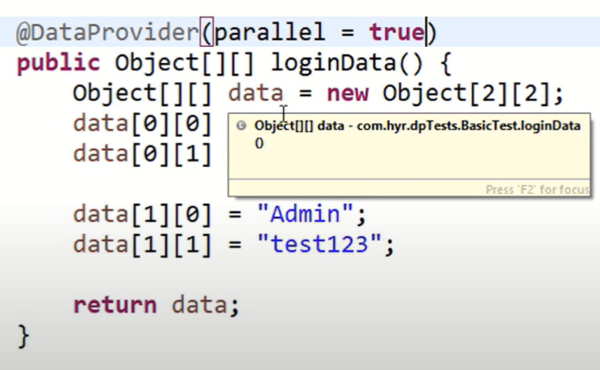

### **In this scenario if I have 200 set of data in dataprovider then 200 browsers will open and network speed (system performance) will become low. Everything will get struck so we need to have some mechanism to control count of execution of browser(how many set of data to execute parallelly). So we need to use dataprovider Threadcount.**

### **This threadcount attribute cannot be specified inside the class we have to specify it in xml**

### **In xml it must be speicified in the suite level not in the test level**

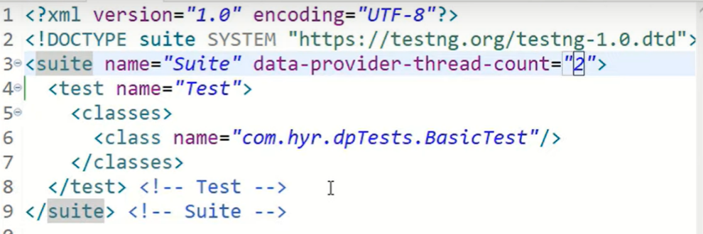

## ****Verbose in xml file****

### **IF you want to get more details in output console then we can increase the verbose value**

### By enabling Verbose mode during automated tests, you can gain additional insights into the execution flow and identify potential issues.

### The verbosity level ranges from 0 to 10, where 10 is the most detailed logging level whereas 0 means minimal logging.

### If dataprovider is present in other class then we have to add one more parameter in the actual method

**dataProviderClass = classname.class**

## **Parallel Tests**

### **Parallel testing or parallel execution, as the name suggests, is a process of running the test case parallelly rather than one after the other**.

### The tester should also know which modules to run in multiple threads and which ones to run in the same threads etc.

### Parallel test execution in TestNG triggers with the help of keyword "**parallel**".

## Run test methods in parallel.

### This will run the parallel tests on all @Test methods in TestNG.

### If a class has multiple methods if we use parallel keyword in suite level then multiple methods will not run sequentially it will execute parallelly in different browsers

## Run test classes in parallel.

### All the test cases present inside the classes that exist in the XML will run in parallel.

### Use parallel = classes

## Run test suites parallel.

### All the test cases present inside the <test> tag will run with this value.

### Use parallel = tests

## Thread-count:

### **The TestNG has a default value of thread = 5 for parallel testing**,

### Thread count is basically number of instances running to execute multiple tests simultaneously or parallelly.

### The attribute thread−count allows the user to specify how many threads should be run for this execution.

### Threads in parallel testing refer to different parts in which the test execution will be divided and run parallelly.

### So, if there are two threads and two methods, they will take one method each and run them parallelly (if we are running the methods parallelly).

### But if there are three methods and two threads, one will have to wait until one thread is free and takes up that method for execution.

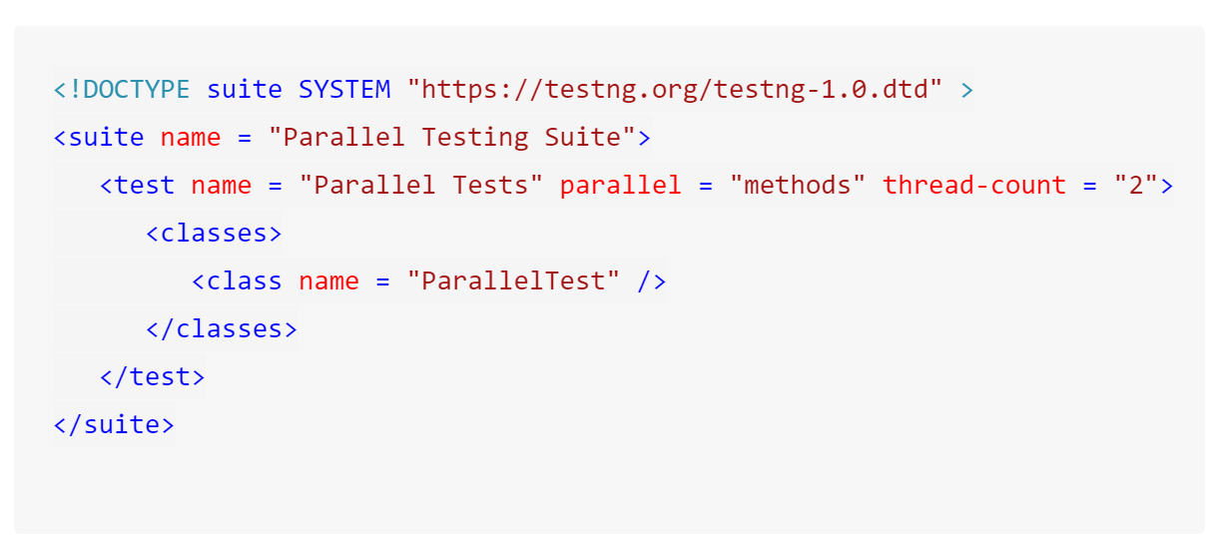

## ****Note****: An extra parameter "****parallel****" is required to initiate parallel execution in TestNG using dataproviders.

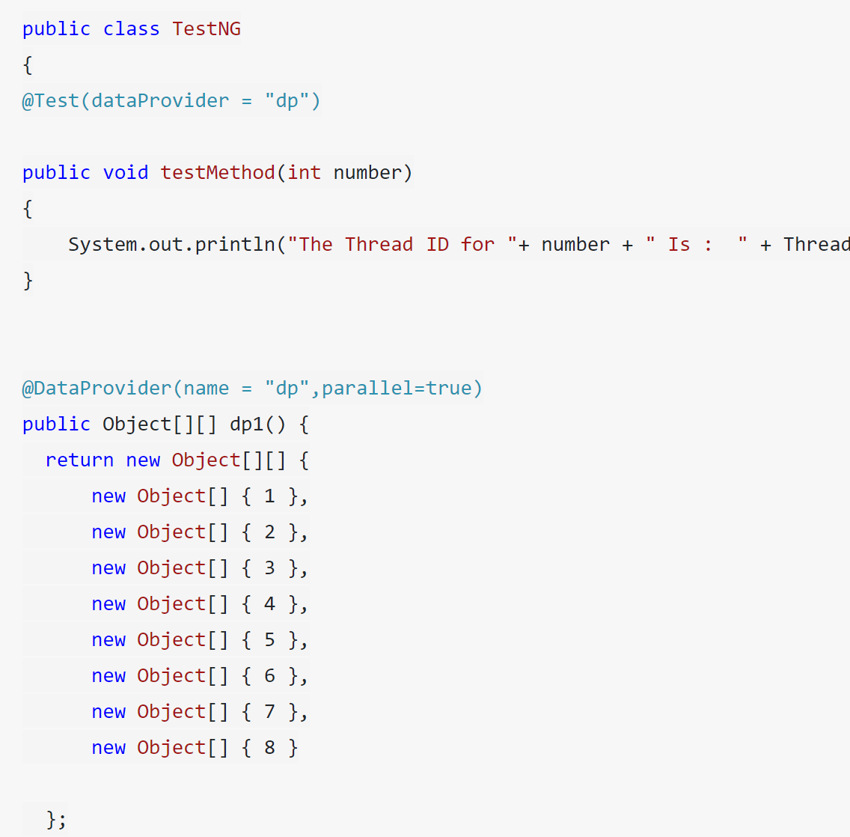

## ****In the XML file, we need to add one more parameter called data-provider-thread-count to mention the thread count we need to initialize****.

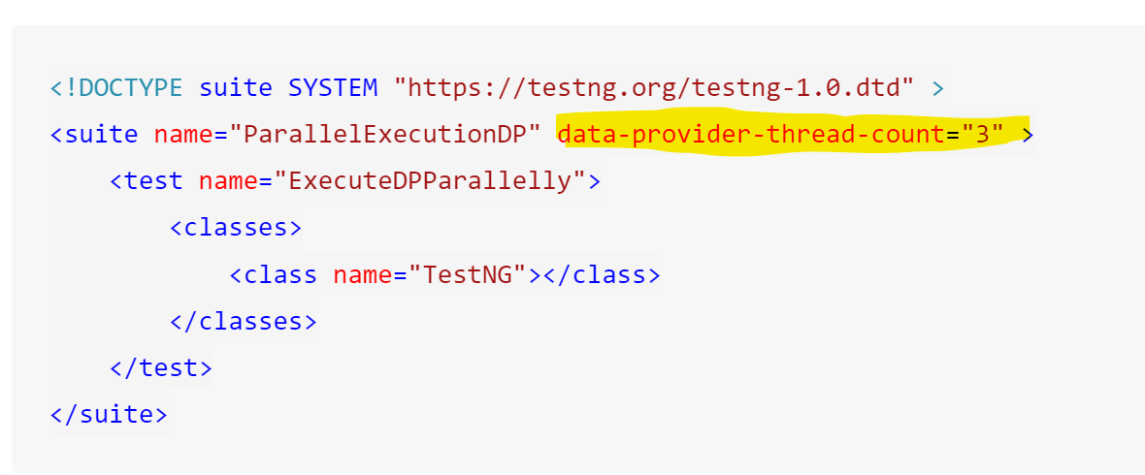

## ****Reports in TestNG****

### **Whenever we execute some test, we need to track some information like status of test execution, how much time it takes to execute all TC, and test is failed what is the exception actually.**

### **Window->show view->console**

### **No where execution time is mentioned in console.**

### **TestNG provide console called TestNG console. It will display all information along with execution time.**

### **Window->show view->other->TestNG**

## ****When we need report if we have TestNG console?****

### **Mistakenly closed eclipse or console**

### **To check the report frequently or after one day**

### **To send status execution to management to review**

### **To check last execution details**

### **In console if data is loss, it is loss**

### **So, for this we need a mechanism to store the execution information**

### **Report is a file will store the execution details into one file and that file will be saved in OS. Even if u shutdown the system the file will not be deleted.**

### **TestNG will generate report by default.**

### **When u execute the class TestNG will create XML file default and execute it internally if we didn’t create XML file also**

### **In real time we will not use TestNG reports**

### **Management will expect beautiful UI and more features in the report like screenshot, log attachments, filtering, searching etc.**

### **All those things are not available in the default TestNG reports.**

## ****Alternate for TestNG reports****

### **Extent Report**

### **Allure Report**

## ****Integration Extent report with TestNG****

### **Annotations Level**

### **Listener Level**

## Listeners:

### Based on the results of the Test methods if I want to perform certain kind of actions then it is called post actions

### These post actions can be performed only using listeners.

### Listeners are automatically triggered based on the result of the Test methods.

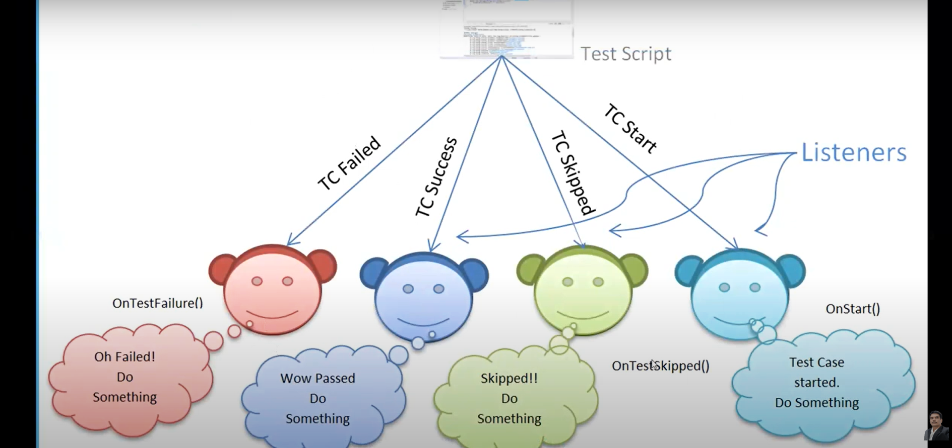

## Types:

## iTestListener(popularly used listener)

### This is an interface. It contains many methods like

## onStart (ITestContext arg0)

### Invoke after the test class is instantiated and before any configuration method is called. Execute only one time.

## onFinish (ITestContext arg0)

### Involve after all tests run and all their configuration methods have been called. Execute only one time.

## onTestFailure(ITestResult arg0)

### Invoke each time when test fails.

## onTestSkipped(ITestResult arg0)

### Invoke each time when test skips.

## onTestStart (ITestResult arg0)

### Involve each time when a test will be invoked

## onTestFinish(ITestResult arg0)

### Invoke each time when test succeeds.

## onTestFailedButWithinSuccessPercentage(ITestResult arg0)

### Invoked each time a method fails but has been annotated with success percentage and this failure still keeps it withing the success percentage requested.

## When we try to implement interface we have to define all the methods within the class

## Approach 1: Integrate listeners using class level.

### Now integrate Test class with customized test listener class by adding annotation @Listeners(packagename.listenerclassname.class)

### Mention Listener annotation in the class level

### These are abstract methods, and we have to implement in according to our requirement.

### Create separate java class and name it as listeners (any name)

### Implement iTestListener interface.

## Approach 2: Using XML file

### Define listener tag in xml before test tag

<listener>

<listener class-name =” packagename.listenerclassname.class”>

</listener>

## Retry Logic

### **Couple of chances to the specific failed test cases to be executed once again**

## Some Script failure can be because of following reasons.

### Random browser issues or browser becoming unresponsive.

### Random machine issues

### Server issues like unexpected delay in the response from server

### These failures are genuine and should be investigated but these failures are not necessarily because of a bug in the product.

## It can be done in two ways

### By specifying retryAnalyzer value in the @Test annotation

### During run time by implementing on the other Listener (IAnnotationTransformer) interface

## In order achieve this we have to first understand the org.testng.IRetryAnalyzer interface. The interface definition is

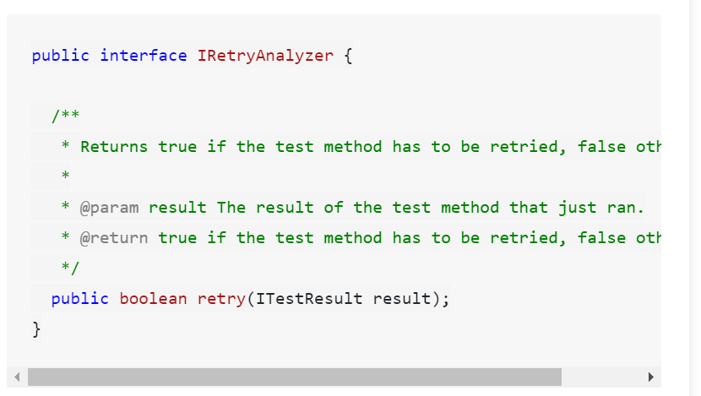

## The IRetryAnalyzer interface has one method retry()

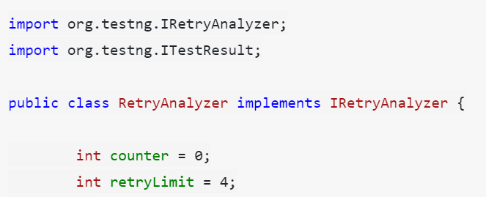

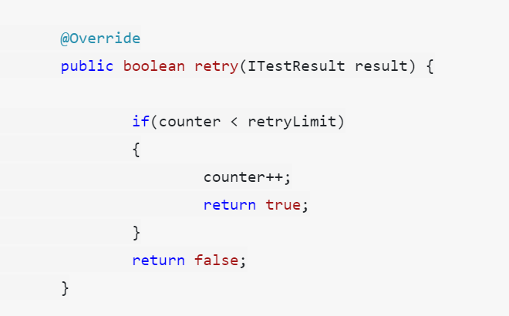

## To implement this in methods we have to use attribute retryAnalyzer

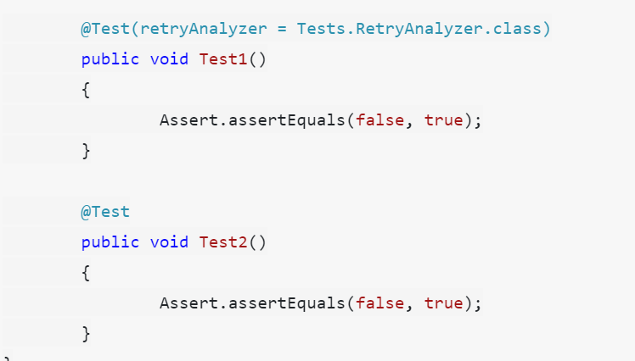

### But if we have 40 methods then for each method, we have to add that attribute

### To overcome that we have on more listener IAnnotationTransformer

### This interface is used to programmatically add annotation to your test methods during run time

### Below Listener

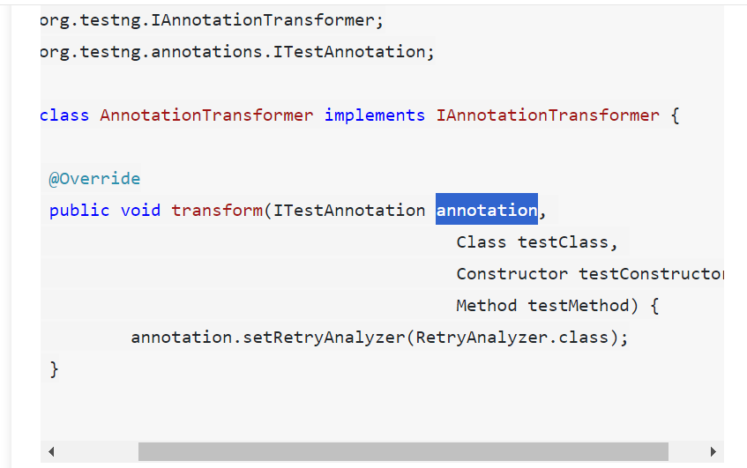

### Once we have the implementation of IAnnotationTransformer, we just need to add it as a listener in the testng run xml. Like this

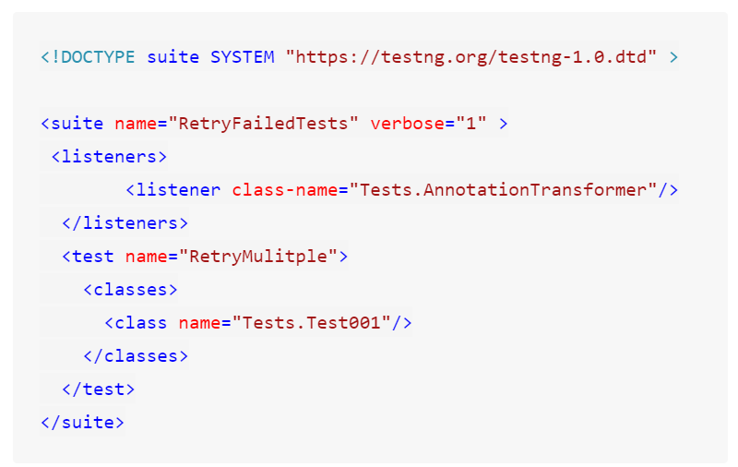

## ****TestNG Reporter class****

### **If you need to log messages that should appear in the generated HTML reports, use Reporter class.**

## ****Reporter.log(“Message”);****

### **It will print log messages in both console and report**

### **During and after test execution only Reporter log will be applicable**